Southern Tier Chapter of
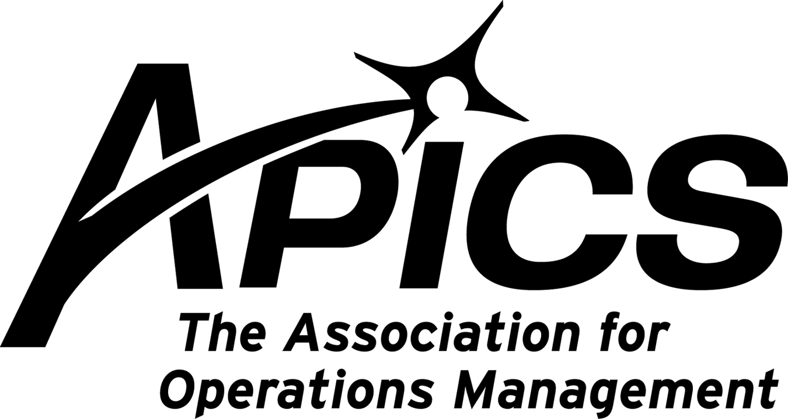
www.stapics.org

“Advancing productivity and innovation and competitive success.”

DINNER MEETING

Thursday, March 22, 2012

Location: Relief Pitcher,
195-197 Conklin Avenue, Binghamton, lower level room

Guest Speaker:
Michael Ford

Ice Cream Sundae Production: From Job Shop to Lean Flow

Are you interested in comparing a job shop layout to a lean flow line? Or maybe you just missed dessert? Either way, this session will be an instructive and tasty experience!

This interactive workshop will engage you and your fellow participants by role-playing as customer order entry professionals, production planners, workstation operators, inspectors or hungry customers placing orders. The session involves two major exercises: first, a simulation of a traditional job shop layout; and then, creation of a flow line to demonstrate the improved lean environment.
Attendees will gain knowledge of the following concepts:
- The advantages of empowerment and engagement
- Lean improvements in productivity, space requirements, lead time and quality
- Some secrets you never knew about Lean (which contradict the so-called “experts”)!
This experiential learning session provides valuable lessons learned that the audience will remember years or decades later. Participants engaged in a simulation will retain more information than the standard lecture format.
5:30PM Registration and Networking
6:00PM Dinner (Buffet Style)
Soup du Jour, Tossed Salad, Vegetable, Potatoes, Baked Ziti, Baked Chicken, Bread
6:45PM Announcements (5 mins for each organization)
7:05PM Presentation
8:30PM end (takes a bit longer due to hands-on nature)

Cost: $25. Includes coffee & tea. All other drinks are additional.

RSVP by 3/16/12 to Michael.LoSapio@SynergyResources.net.

Thanks and hope to see you there!

APICS Southern Tier, & Broome Community College offer
Six Sigma White Belt Certification

Course Description

This 8-hour course is designed for people interested in adding Six Sigma to their resume, the person curious about Six Sigma methodologies, or the person seeking an introduction to Six Sigma techniques but is not yet ready for the riggers of Green or Black belt training (which can involve weeks of training and application). This course is also appropriate for people who may not be ready to tackle the heavy statistical requirements of the higher level Six Sigma belt requirements. This course will include an overview of the major methodologies used in Six Sigma. At the end of the session a certification test on the materials covered will allow successful attendees to receive Six Sigma White Belt Certification sanctioned by APICS Southern Tier Chapter, DHSheldon & Associates and Broome Community College.

Open below attachment for more details.

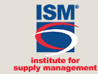

ISM's 97th Annual International Supply Management Conference and Educational Exhibit

May 6 to May 9, 2012
Baltimore, Maryland


To learn more, visit: http://www.ism.ws/confplanner/conf.cfm?confID=36



We’re on !!!
Come and visit, poke around, or comment on us! Our name there is “Southern Tier APICS”. It’s just another way
for us to keep in touch with our membership.

Board of Directors 2011-2012

President Director of Publicity
Dave Gardner Kelly Norieka
dgardner@akraturn.com Kelly.norieka@lmco.com

Executive VP /Director of Finance Director of Education
Steve Whited Don Sheldon
sjw6@meadwestvaco.com dsheldon@sheldoninc.com

Secretary Director at Large
Debbie Unkel Steve Stanchak
deb.unkel@raymondcorp.com steve.stanchak@infoprint.com

Director of Membership/Director of Chapter Standards/

Director of Online Publication Director of Student Relations
Lee Schechter Brian Arrnold
lschechter@stny.rr.com barnold@amphenol-aao.com

Director of Programming and Marketing Director of Communications
Michael LoSapio April McWeeney
Michael.LoSapio@SynergyResources.net april.mcweeney@mwv.com

Southern Tier APICS
PO Box 1107
Binghamton NY 13902-1107

